EXPERIMENT – 8
PREDICTING MODEL -KNN
Aim:
To perform model classification using K-nearest neighbours

Procedure:
1. Upload a given dataset
2. Import all necessities
3. Read and make it as data frame
4. Through sklearn train the model
5. Test the model

Program:
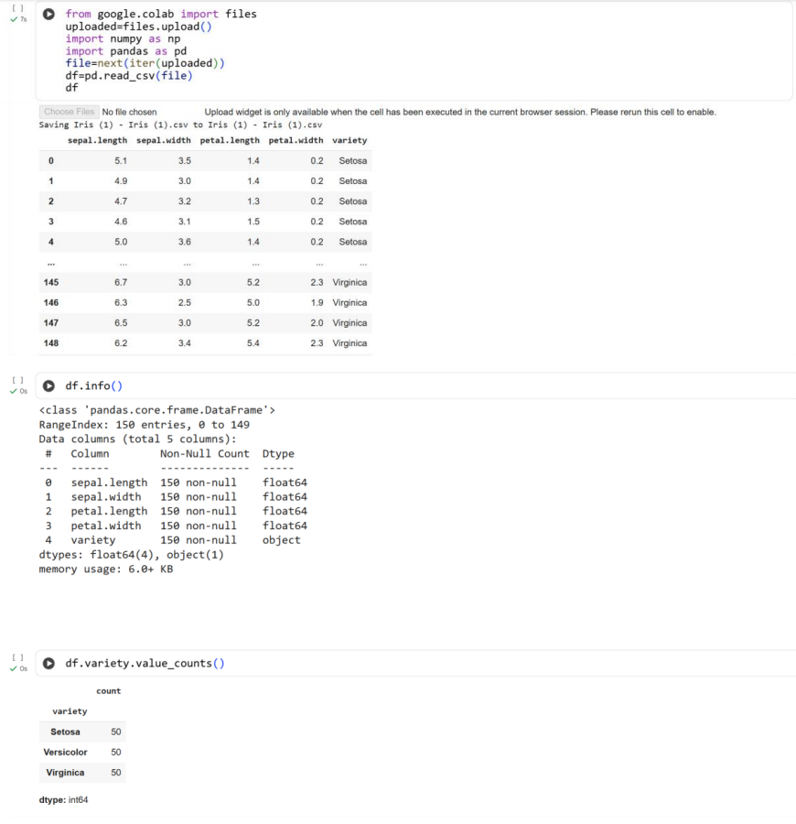
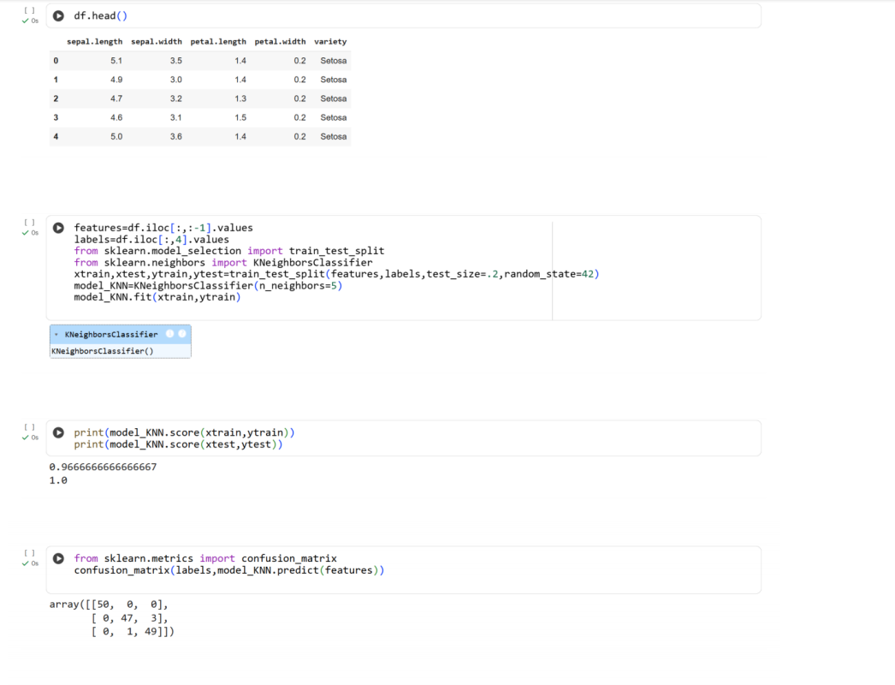
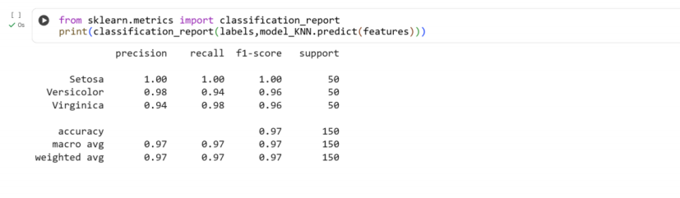
Result:
Thus the python program to perform model classification using KNN is executed and
verified

